**Mnemonic Device:**

**A method of reorganizing information to make the information easier to remember.**

Music has an almost magical ability to transport us to a different place or time. It does so by tapping into several different [brain networks](https://www.psychologytoday.com/us/blog/the-athletes-way/201312/why-do-the-songs-your-past-evoke-such-vivid-memories) and creating stronger memory connections. Music is not the only medium we can use to tap into this potent memory phenomenon. Sounds, words, and imagery can all be used to help us remember specific information. As designers and educators, we can exploit this reality via the design principle of the mnemonic device, which is a method of reorganizing information to make the information easier to remember. These mnemonic device has been in use since before the time of [Aristotle](https://www.researchgate.net/publication/261760419_A_Brief_History_of_Mnemonics). A use case we may already be familiar with helps children remember the visible colors of the rainbow in the form of ROY-G-BIV. In this example, we have a male-sounding that helps recall that the visible colors of the rainbow are: Red, Orange, Yellow, Green, Blue, Indigo, Violet. Remembering the colors of the rainbow might seem like a novel use, however, an instructional designer, trainer, or educator might choose to utilize a Mnemonic Device for a broad range of scenarios where remembering specific information is important.

Mnemonic Devices are effective memory tools because they capitalize on the brain's bias towards association and novelty. Additionally, they sync well with proven design concepts such as stickiness, chunking, and the von Restorff Effect. A couple of things happen in the brain when using an effective mnemonic device: 1) It creates an association between something we already know and something we are trying to remember. The brain is constantly looking for associations, usually at the subconscious level, because doing so saves mental calories, and helps things fit in the bigger pattern. 2) It also utilizes novelty, something the brain tends to pay attention to because new and different are more noticeable and memorable. Effective mnemonic devices also align with several [UDL](http://udlguidelines.cast.org/) principles. Namely Perception, Language & Symbols, Comprehension, and Expression & Communication. Ease of memory is a straightforward reason to use a mnemonic device, and here are several established techniques to help us do just that.

**First-Letter Mnemonic Device**

Our previous example of ROY-G-BIV is an instance of using the first letter of each word in a data set to create a new word sequence that is easier to remember. Also referred to as acrostics, this method is a great way to create novel associations that stick. Here we see two examples. PEMDAS, a commonly used mnemonic, which helps elementary students remember the mathematical order of operations. We also see here a creative hybrid approach that uses both 1st letter and keywords to help students remember Group 1 and group 2 elements of the periodic table.

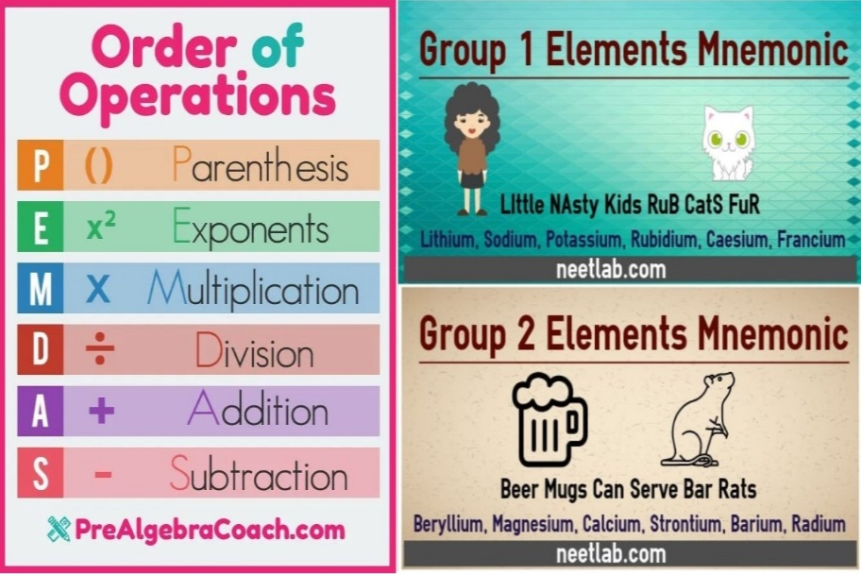

**Keyword Mnemonic Device**

Keyword mnemonic devices use familiar information, words, sounds, or imagery to create an association with new information. This type of mnemonic device has a great deal of utility and can be used across a broad range of topics and settings. Here we see an example of a keyword mnemonic devices to help create keyword associations between content and images. This one is meant to help students remember the cranial nerves and their locations.

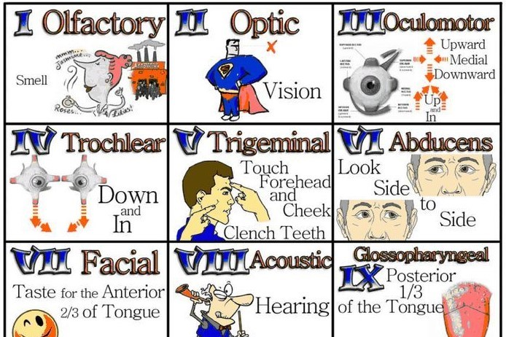

**Rhyme Mnemonic Device**

Rhyme has a unique impact on humans, which activates specific brain areas that are different from other auditory signals. This difference helps make things stick. We can capitalize on this stickiness via the Rhyming Mnemonic Device, which has likely been used since the dawn of civilization to help pass oral tradition from one generation to the next. Here are two prime examples of using the power of rhyme to remember concepts that are challenging for many people.

30 days hath September, April, June, and November. All the rest have 31. Except February my dear son. It has 28 and that is fine. But in Leap Year it has 29.

"I" before "e" except after "c" or when sounding like "a" in "neighbor" and "weigh" .

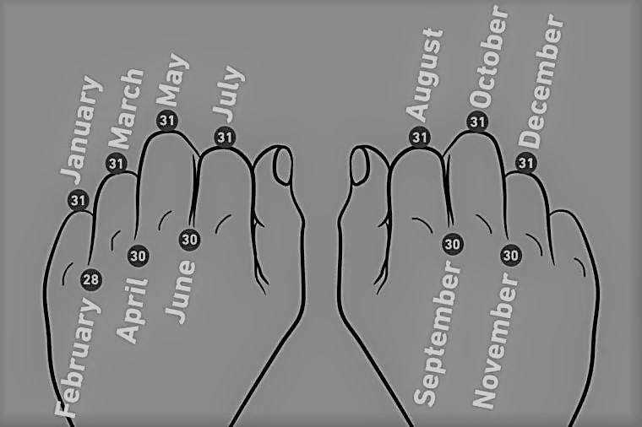

**Feature-Name Mnemonic Device**

Feature-Name Mnemonic Devices use specific imagery to elicit a visual cue and create an association. These devices fill a slightly narrower, yet powerful, use case where specific features of an entity are used to aid recall. The Purdue Online Writing Lab logo is a good example because it ties in several visual associations that make it easy to remember both what it does and what it symbolizes.



**Method of Loci**

Another ancient memory technique is the Method of Loci mnemonic device, also known as the Memory Palace, which has helped stage performers and the like remember their lines as least as far back as [500 B.C.](https://www.verywellhealth.com/will-the-method-of-loci-mnemonic-improve-your-memory-98411) This technique uses visualization to mentally organize information by associating it with a known physical space. For example, modern memory athletes often use their homes as the physical space within which they associate a card sequence. Perhaps the Queen of Hearts is the first card in the deck and greets them at the front door, holding six shovels(6 of Spades). This example hosted on Prezi illustrates a way to make it easier to remember the president .

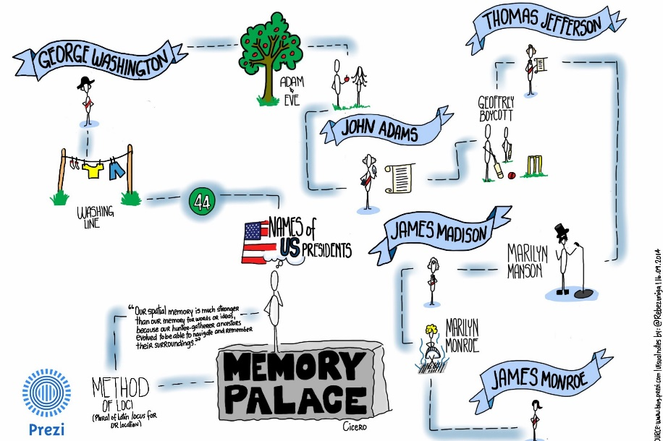

Duane Gregory - WTAMU course 6310 - Summer II - 2020